Reymark Jan T. Gandalla BSIT-2B

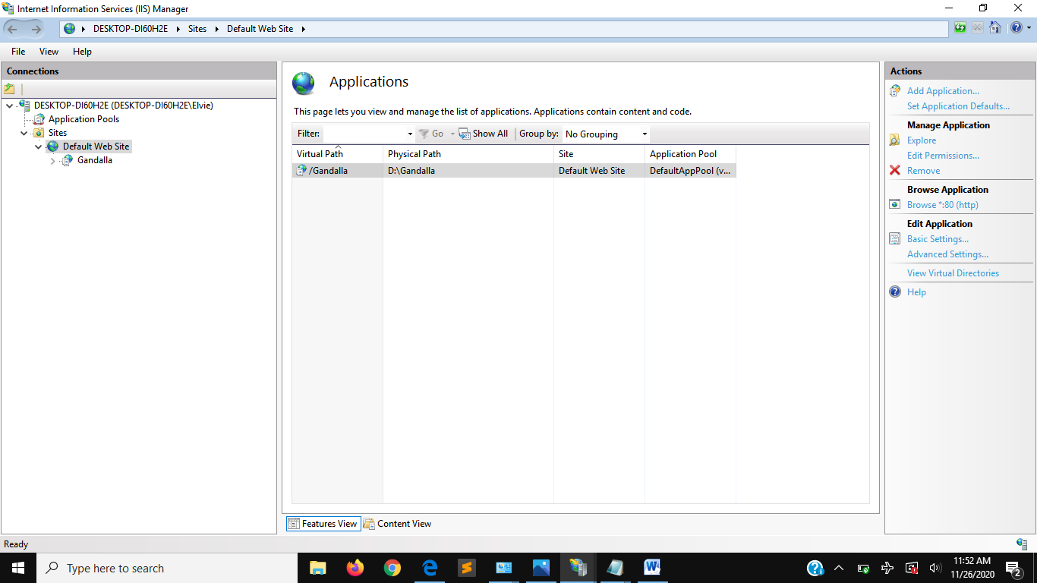
Web Application Configuration

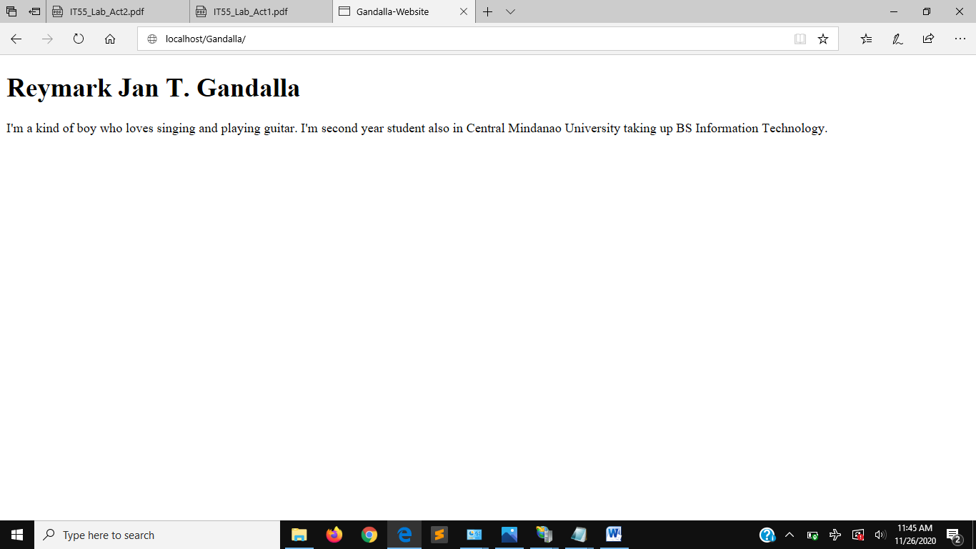
Sample Web Page

